Muhammad Waheed

912741428

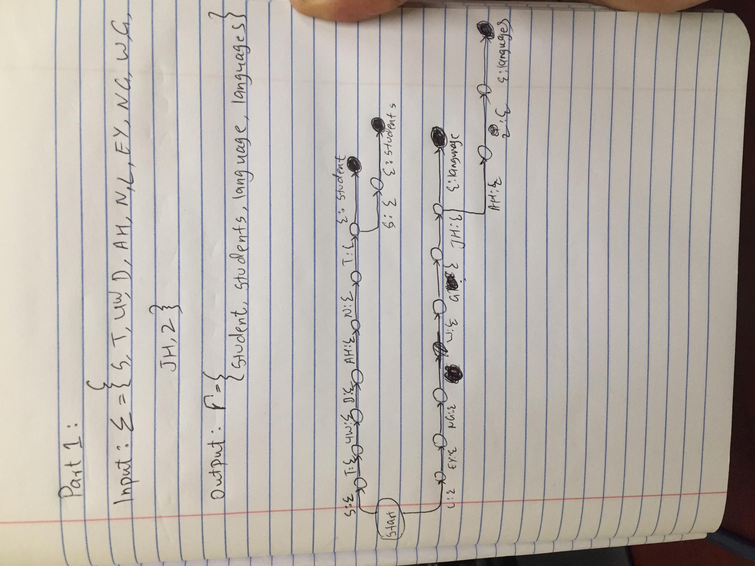

Part 2:

go(CurrentState, InString, OutString):- % Getting standard In and Out

transition(CurrentState,eps,NextState,eps), % From Curr to Next State

go(NextState, InString, OutString). % Goes to next state

Part 3:

go(CurrentState, InString, OutString):- % Getting standard In and Out

transition(CurrentState,eps,NextState,eps), % From Curr to Next State

go(NextState, InString, OutString). % Goes to next state

soundslike(X,Y) :-

fst(Z, X),fst(Z,Y).

Part 3 after running soundslike:

For soundslike([“computational” , “linguistics”], A). The code generated a very big loop. After few iterations I observed the trend of code interpreting the word “linguistics” is same it is being written the same way in all iterations. “Computational” word changes many times, with many different ways and all of them sounds like computational.

